Team Analysis

**Problem 1**

1. Let $f∈C([0,2π])$ with
$$f\left(θ\right)\sim \frac{a_{0}}{2}+\sum_{n=1}^{∞}{(a_{n}cosnθ+b_{n}sinθ)}$$

2. $u_{n}=\frac{a_{0}}{2}+\sum_{k=1}^{n}{r^{k}(a_{R}cosθ+b_{R}sinθ)}$ converges to a harmonic function $u(x,y)$ on every compact subset of $D=\left\{z∈C│\left|z\right|<1\right\}$, where $z=re^{iθ}=x+iy$.
3. $\iint_{D}^{ }{\left(u_{x}^{2}+u_{y}^{2}\right)dxdy=π\sum_{n=1}^{∞}{n(a_{n}^{2}+b_{n}^{2})}}$.
4. Let $f∈C\left(\left[0,2π\right]\right)$ which satisfies for some $α∈\left(\frac{1}{2},1\right)$

$${\left\|f\right\|}_{{\dot{c}}^{α}}=\sup_{x,h∈[0,2π]}{\frac{\left|f\left(x^{-1}h\right)-f(x)\right|}{h^{α}}}<+∞$$

Then we have

$$\frac{\left|a_{0}\right|}{2}+\sum_{n=1}^{∞}{\sqrt{a_{n}^{2}+b_{n}^{2}}≤C{\left\|f\right\|}_{{\dot{c}}^{α}}}$$

**Problem 2**

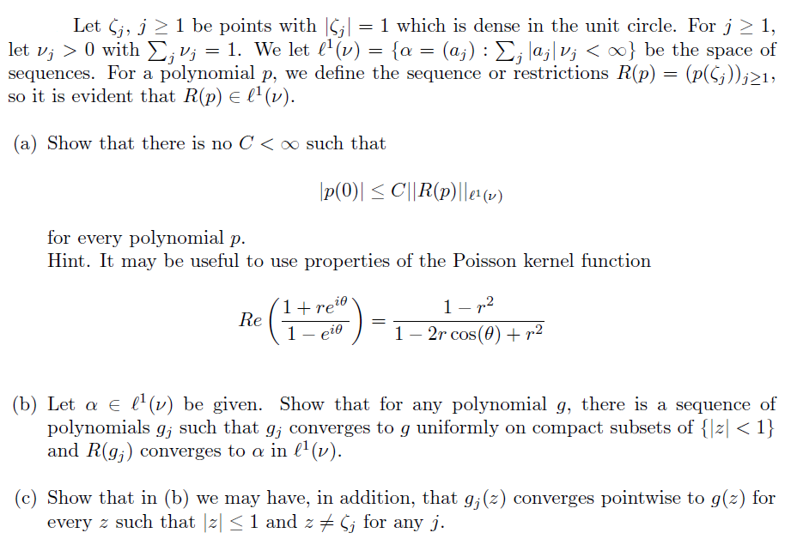

**Problem 3**

Consider the following initial-boundary value problem

$$(*)\left\{\begin{aligned}\frac{∂u}{∂t}-∆u=u^{2} on B_{1}\left(0\right)≡B_{1} \\ \frac{∂u}{∂n}│_{∂B_{1}}=0 n is the outnormal of ∂B_{1} \\ u│_{t=0}=u_{0(x)} \end{aligned}\right.$$

1. Let $u_{1}(t,x)$ and $u_{2}(t,x)$ be two smooth solutions to $(*)$ on $B_{1}×[0,T]$.

If $u_{1}│_{t=0}(x)≥u_{2}│_{t=0}(x)$, $∀ x∈B_{1}$, then

$$u_{1}\left(t,x\right)≥u_{2}\left(t,x\right) on B_{1}×[0,T]$$

1. Let $a$ be a positive constant. Solve $\left(*\right)$ with $u_{0}(x)≡a$ for all $x∈B_{1}$.
2. Assume that $u_{0}\left(x\right)>0$ on $B_{1}$ and $u(x,t)$ be the solution to $\left(*\right)$. Then $∃ T>0$ such that

$$\lim_{t→T^{-}}{\sup_{x∈B_{1}}{u\left(x_{1},t\right)=+∞}}$$

**Problem 4**

Let $f≥0, f∈L^{1}(0,1)$, monotone decrease

Suppose $∀ a,x∈(0,1)$ such that $x-a, x+a∈(0,1)$,

$$\int_{x-a}^{x}{f\left(t\right)dt<\frac{5}{4}\int_{x}^{x+a}{f\left(t\right)dt}}$$

Prove $f∈L^{p}\left(0,1\right), ∀ 1≤P≤\frac{\log{2}}{\log{3}-\log{2}}$